**Networks Fundamentals II Homework: *In a Network Far, Far Away!***

**Mission 1:** Incorrect MX records

Current MX records:

sysadmin@UbuntuDesktop:~$ nslookup -type=mx starwars.com

Server: 8.8.8.8

Address: 8.8.8.8#53

Non-authoritative answer:

starwars.com mail exchanger = 10 aspmx3.googlemail.com.

starwars.com mail exchanger = 1 aspmx.l.google.com.

starwars.com mail exchanger = 5 alt1.aspx.l.google.com.

starwars.com mail exchanger = 5 alt2.aspmx.l.google.com.

starwars.com mail exchanger = 10 aspmx2.googlemail.com.

Authoritative answers can be found from:

sysadmin@UbuntuDesktop:~$

The new mail servers built are:

asltx.l.google.com

asltx.2.google.com

As the old mail servers were brought down by the Empire, and the DNS records are not updated to point to the newly built mail servers, none of the emails are being received by the new mail servers.

The fixed records should read as below:

starwars.com mail exchanger = 1 asltx.l.google.com.

starwars.com mail exchanger = 5 asltx.2.google.com.

**Mission 2:** Incorrect spf record

sysadmin@UbuntuDesktop:~$ nslookup -type=txt theforce.net

Server: 8.8.8.8

Address: 8.8.8.8#53

Non-authoritative answer:

theforce.net text = "v=spf1 a mx mx:smtp.secureserver.net include:aspmx.googlemail.com ip4:104.156.250.80 ip4:45.63.15.159 ip4:45.63.4.215"

theforce.net text = "google-site-verification=XTU_We07Cux-6WCSOItl0c_WS29hzo92jPE341ckbOQ"

theforce.net text = "google-site-verification=ycgY7mtk2oUZMagcffhFL_Qaf8Lc9tMRkZZSuig0d6w"

Authoritative answers can be found from:

sysadmin@UbuntuDesktop:~$

The current SPF record is "v=spf1 a mx mx:smtp.secureserver.net include:aspmx.googlemail.com ip4:104.156.250.80 ip4:45.63.15.159 ip4:45.63.4.215"

It is missing the IP of the new server which is why the emails are ending up in the spam.

The update record should include the new ip like:

theforce.net text = "v=spf1 a mx mx:smtp.secureserver.net include:aspmx.googlemail.com ip4:104.156.250.80 ip4:45.63.15.159 ip4:45.63.4.215 ip4:45.23.176.21"

**Mission 3**: CNAME issue

The CNAME records should look like:

sysadmin@UbuntuDesktop:~$ nslookup -type=cname www.theforce.net

Server: 8.8.8.8

Address: 8.8.8.8#53

Non-authoritative answer:

www.theforce.net canonical name = theforce.net.

Authoritative answers can be found from:

Where as resistance.theforce.net is not returning any CNAME entries which indicates that the CNAME records are missing.

sysadmin@UbuntuDesktop:~$ nslookup -type=cname resistance.theforce.net

Server: 8.8.8.8

Address: 8.8.8.8#53

** server can't find resistance.theforce.net: NXDOMAIN

sysadmin@UbuntuDesktop:~$

The CNAME record should look like this:

resistance.theforce.net canonical name = theforce.net.

**Mission 4**: Additional Name Server

The present NS records for the domain princessleia.site are:

sysadmin@UbuntuDesktop:~$ nslookup -type=NS princessleia.site

Server: 8.8.8.8

Address: 8.8.8.8#53

Non-authoritative answer:

princessleia.site nameserver = ns25.domaincontrol.com.

princessleia.site nameserver = ns26.domaincontrol.com.

Authoritative answers can be found from:

sysadmin@UbuntuDesktop:~$

Eventhough it have a backup server configured still is missing the new backup DNS server entry in it.

The only way to beat the downtime is planning redundancy and make sure atleast one server is accessible to the client. So if we add the new backup server to the above list, it will improve the availability. Also, definitely suggested to backing up on a regular basis to bring up another server in the instance of all the published servers are brought down at once.

The new update records should be:

princessleia.site nameserver = ns25.domaincontrol.com.

princessleia.site nameserver = ns26.domaincontrol.com.

princessleia.site nameserver = ns2.galaxybackup.com.

**Mission 5:** OSPF shortest path

The OSPF shortest path is:

Batuu - D - C - E -F - J - I - L - Q - T - V - Jedha with a total path cost of 23.

**Mission 6:** pcap file

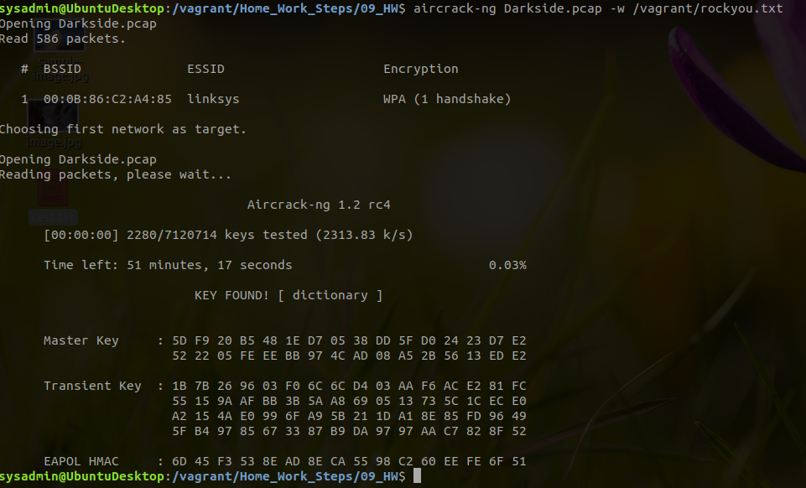

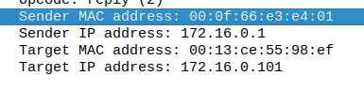

**Mission 7** :

sysadmin@UbuntuDesktop:/vagrant/Home_Work_Steps/09_HW$ nslookup -type=txt princessleia.site

Server: 8.8.8.8

Address: 8.8.8.8#53

Non-authoritative answer:

princessleia.site text = "Run the following in a command line: telnet towel.blinkenlights.nl or as a backup access in a browser: www.asciimation.co.nz"

Authoritative answers can be found from:

sysadmin@UbuntuDesktop:/vagrant/Home_Work_Steps/09_HW$ telnet towel.blinkenlights.nl

Telnet eventually failed, so accessed using the browser and here is the result.

